Module II. Who Am I?
Topic: The Big Five Personality Traits and Multiple Intelligences
Objective(s): Students will:
1.0 Identify individual interests, strengths, and personality traits.
Goals: Students will learn about their personality types by taking the Big 5 Personality Test. Understanding the type(s) of personality a student possess will help in understanding who the student is and can help in selecting careers that are more conducive to his/her personality and success.
Length: One class periods
Materials:
- Handout – The Big Five Personality Scores Sheet
Description of Activity:
The Big Five Personality
- Students will go to the website below and answer the 46 questions to determine their Big Five Factor Personality trait. The Big Five Factor Personality Inventory measures Openness, Conscienciousness, Extraversion, Agreeableness and Neuroticism (meaning Nervousness), known as OCEAN. After students have answered the questions, and entered their gender and age, they can proceed to the next page to see their score on the five factors.
This self-inventory will take about 10 minutes.
http://www.outofservice.com/bigfive
- Students should type the results for each of the five factors as reported on the second page of the test onto the “Personality Survey Score Sheet”
- Teacher should hold an in-class discussion on the Big Five Traits (shown below) and their meaning, and ask students to share their results as part of the interactive in-class discussion.

Multiple Intelligences
- Teachers will review the “Multiple Intelligences” slides (embedded toward the end of this lesson plan) suggested by Howard Gardner. The theory of multiple intelligences was developed in 1983 by Dr. Howard Gardner, professor of education at Harvard University. It suggests that the traditional notion of intelligence, based on I.Q. testing, is far too limited. Instead, Dr. Gardner proposes nine different intelligences to account for a broader range of human potential in children and adults. These intelligences are:
- Linguistic intelligence (“word smart”)
- Logical-mathematical intelligence (“number/reasoning smart”)
- Spatial intelligence (“picture smart”)
- Bodily-Kinesthetic intelligence (“body smart”)
- Musical intelligence (“music smart”)
- Interpersonal intelligence (“people smart”)
- Intrapersonal intelligence (“self smart”)
- Naturalist intelligence (“nature smart”)
- Existential intelligence (“philosophical smart”)

- The teacher can display a visual of the intelligences (shown below) and students will identify their predominant ones and ask a few students to share their conclusion.
- Group Students by their Multiple Intelligence and ask them to list additional careers beyond those listed on the visual.

Storing Worksheet(s):

If desired and possible, students may store their completed worksheet for this lesson in their personal electronic folders on the school’s computer system that can be retrieved later, if needed.
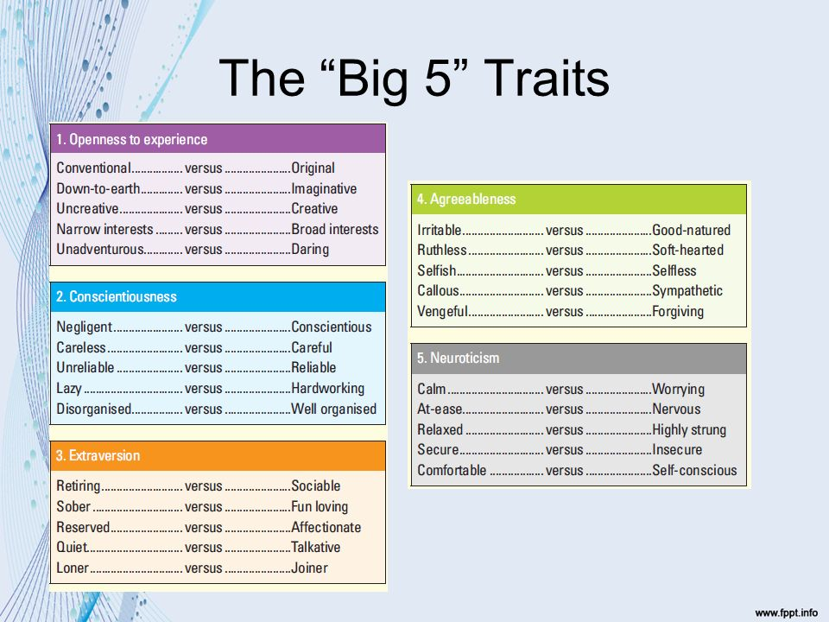

Multiple Intelligence

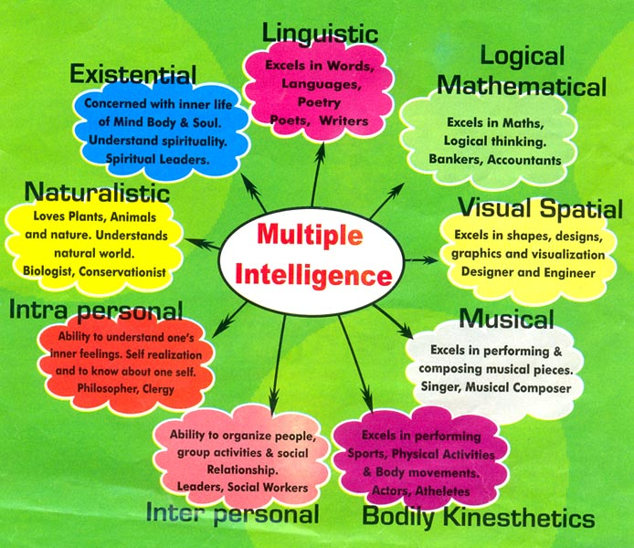

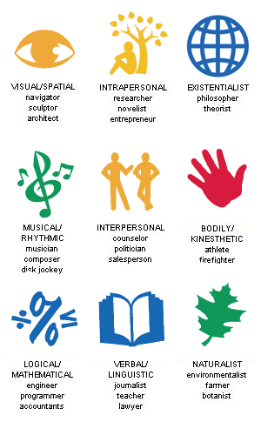

Lessons Learnt:

- Do students know what the Big 5 personality traits are and what are Multiple Intelligences?
- Do they know why would they want to know this information about themselves?

