Module II: What Do I Want to Do?
Topic: Piecing Together the Career Cluster Model
Objective (s): Students will:
- Explore and understand the framework of the Career Fields/Career Clusters model.
- Develop skills to locate, evaluate, and interpret career information.

Goals: Students will:
Learn about the Career Fields/Career Clusters Model, the career pathways, the salary ranges, and Plan of Study for each of the sixteen career clusters.
Length: Four class periods to cover all sixteen career clusters
Materials:
The Career Cluster Model (pages 4-6) and sixteen Career Clusters slides
Description of Activity:

- Using the Career Cluster Model (embedded at the end of this lesson plan on pages 4-6), the teacher will introduce the concept that careers can be grouped into career fields and career clusters. Each career field consists of one or more career clusters. Six career fields make up a total of sixteen career clusters. Some career fields consist of one career cluster while other career fields include multiple clusters.

All sixteen career clusters will be briefly introduced so students can have an understanding for them when deciding on their career. Make sure students understand what kind of careers each cluster entails.

- The teacher will then refresh/review the Essential Knowledge and Skills (shown in the middle of the Career Cluster Model and are listed below) that are fundamental for success in any career:

  - Academic Foundations
  - Communications
  - Employability and Career Development
  - Ethics and Legal Responsibilities
  - Information Technology Applications
  - Leadership and Teamwork
  - Problem Solving and Critical Thinking
  - Safety, Health, and the Environment Systems
  - Technical Skills
- The rest of the lesson will introduce students to each of the sixteen careers cluster including information regarding career pathways, some examples of occupations in each cluster and levels of Education and Earnings nationally and in Arizona. Also shown is a recommended Career Plan of Study for each cluster.

Teachers will use the slides associated with each cluster to deliver the content for each cluster. Start by showing the video clipping describing each career cluster. Link to the video clips for all the clusters are shown on the Curriculum site. Note that most video clips range from 3-5 minutes long.

The sixteen power points associated with the sixteen career clusters are listed below. Our recommendation is to cover each Career Field that has four Career Clusters in one class period. The remaining Career Fields of Environmental and Agricultural Systems, Communications and Information Systems, and Health Sciences can be taught together in one class period. Covering all sixteen career fields can take up four class periods.

If time is constrained, the teacher may choose to focus on the career fields and career clusters that are most interesting or relevant to the classroom students.
- Career Field: Business, Marketing, and Management
- Marketing
- Finance
- Business Management and Administration
- Hospitality and Tourism
- Career Field: Environmental and Agricultural Systems
- Agriculture, Food & Natural Resources
- Career Field: Communications and Information Systems
- Arts, A/V Technology, and Communications
- Information Technology
- Career Field: Industrial, Manufacturing and Engineering Systems
- Manufacturing
- Transportation, Distribution, and Logistics
- Science, Technology, Engineering, and Mathematics (STEM)
- Architecture and Construction
- Career Field: Health Sciences
- Health Sciences
- Career Field: Human Services and Resources
- Law, Public Safety, and Security
- Human Services
- Government and Public Administration
- Education and Training

The Career Cluster Model

A career cluster is a tool for organizing occupational information. Each cluster of occupations shares a common function, such as the cluster Health Services--involves caring for others’ health.

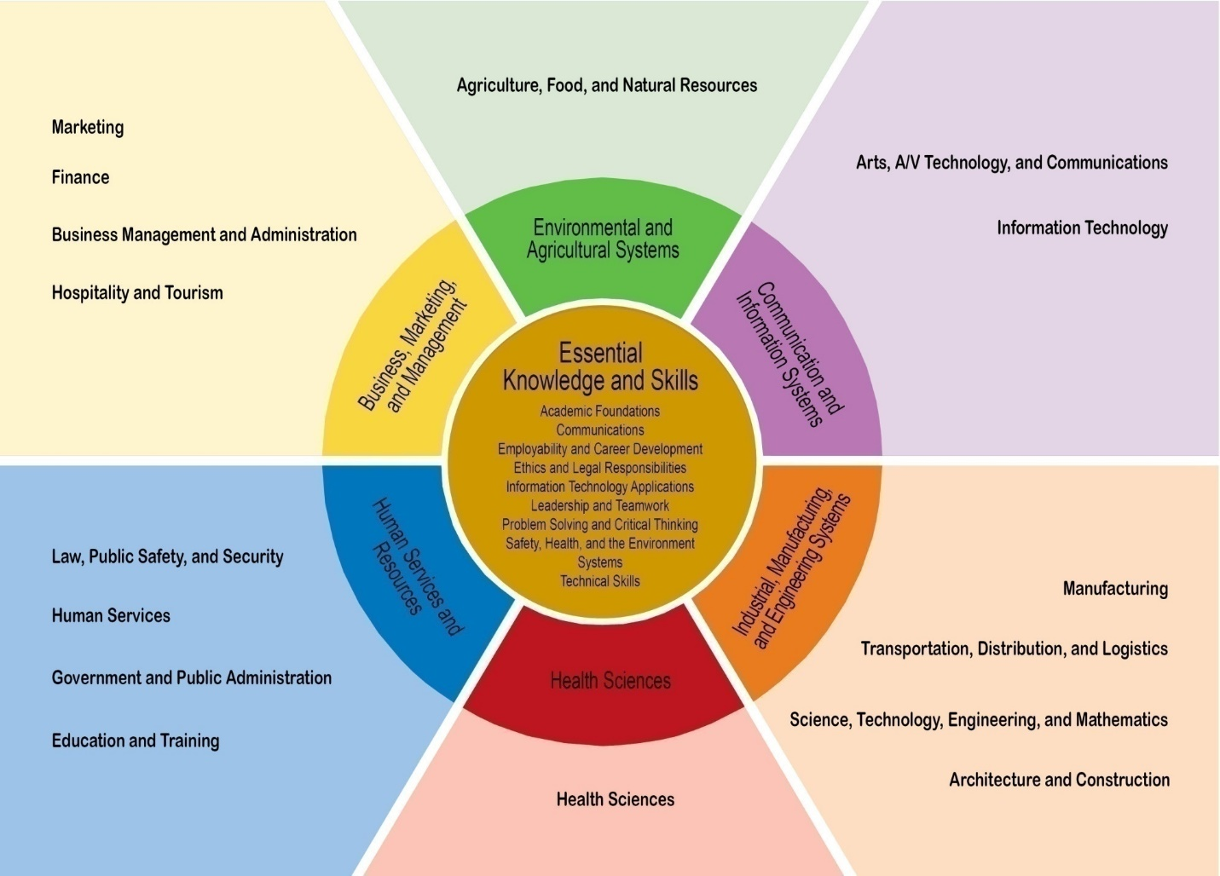
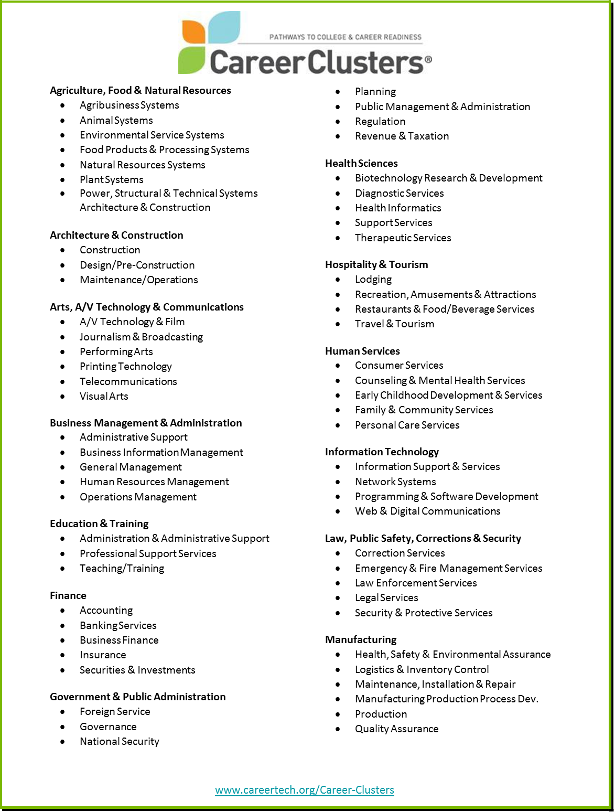
The Sixteen Career Clusters
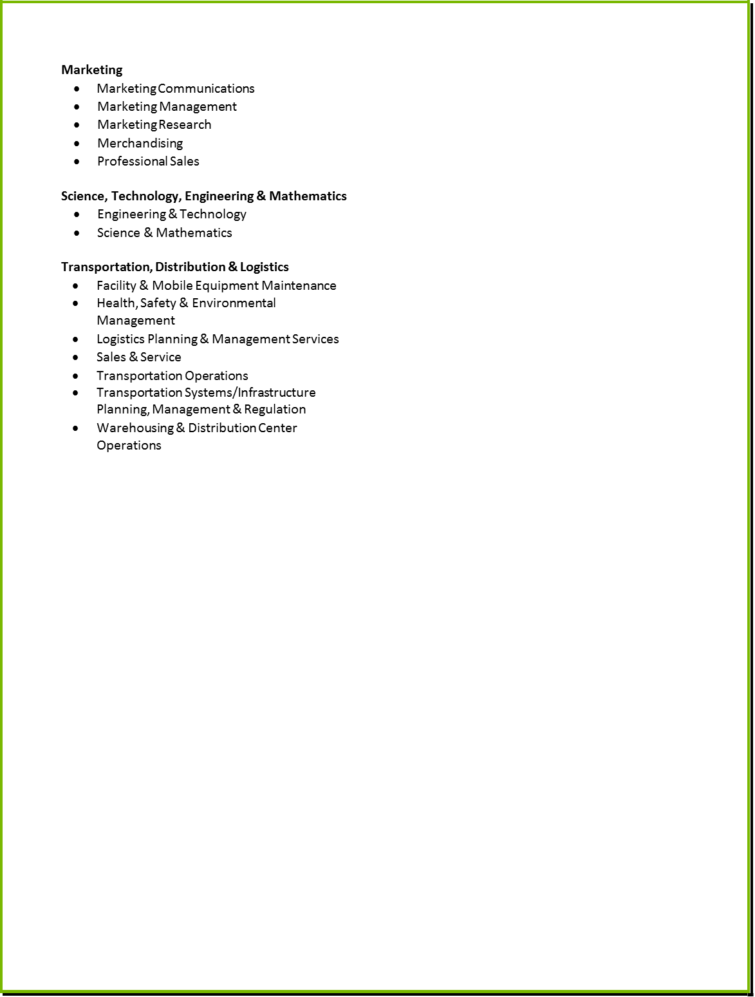
The Sixteen Career Clusters

