Module III: What Do I Want to Do?
Topic: Career Cluster Inventory and Occupation Research
Objective(s): Students will:
- Develop skills to locate, evaluate, and interpret career information.
- Understand the relationship between educational achievement and career choices/postsecondary options.
- Identify career clusters and related pathways through an interest assessment that match career and education goals.

Goal(s): Students will:
Take a Career Cluster Inventory Assessment using AzCIS to see how their interest line up with the sixteen career clusters.
Length: one class periods
Materials:
Access to AzCIS
Description of Activity:

- Students will use AzCIS to do their career cluster inventory assessment using the following steps:

- Sign onto AzCIS Middle School Site and move the mouse cursor over the “WHO AM I?” from the top bar menu

- Select “Career Cluster Inventory (Full Version)” from the Tools drop down menu to get to the Career Cluster Inventory page. Rate each of the 80 activities as “Like very much, Like, Not sure, or Dislike”. This inventory will take about 10 minutes.

- A bar chart showing the scores for each of the sixteen career clusters will be displayed in ranked order, an example is shown below.

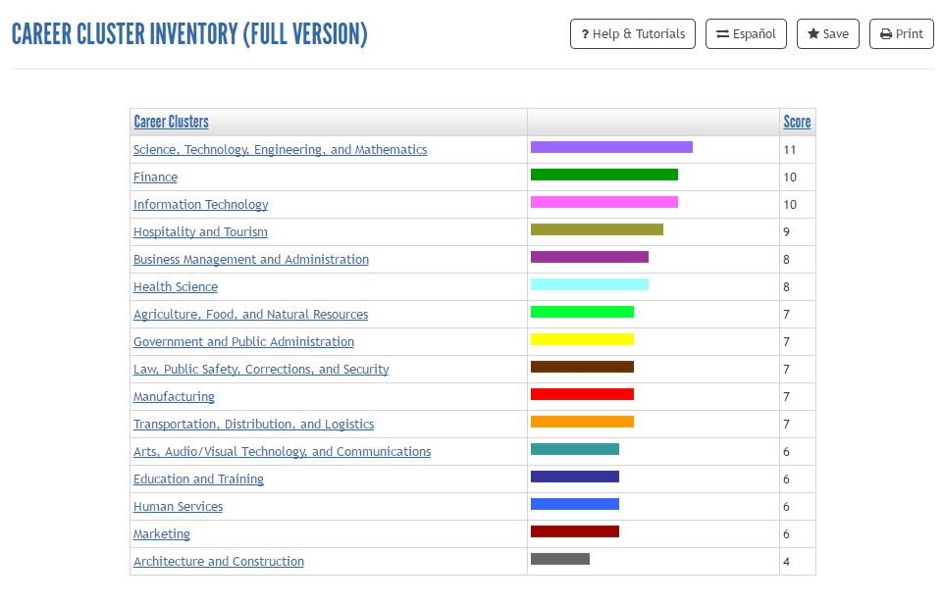
- IMPORTANT – Make sure students click on the SAVE button to save their Career Cluster Inventory chart else the data will be lost. A screen like the one shown below is displayed once the SAVE button is selected. To retrieve the information saved for a later session, click on “Restore Answer Set 1” link. If multiple saves are done, they will be listed with the saved dates indicated.
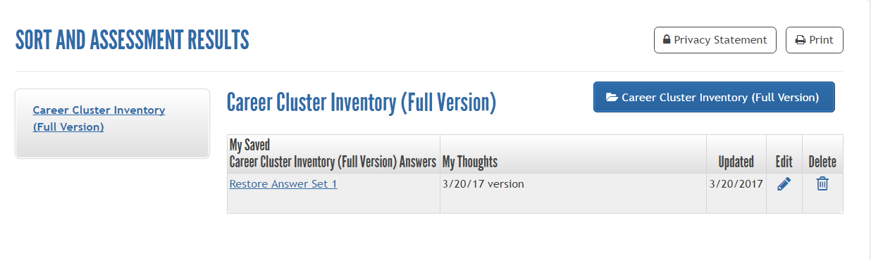

- Clicking on one of these career clusters link above will bring up the details of that cluster. For example, by clicking on the Business Management and Administration cluster, the following screen will appear with more details provided for this specific cluster.

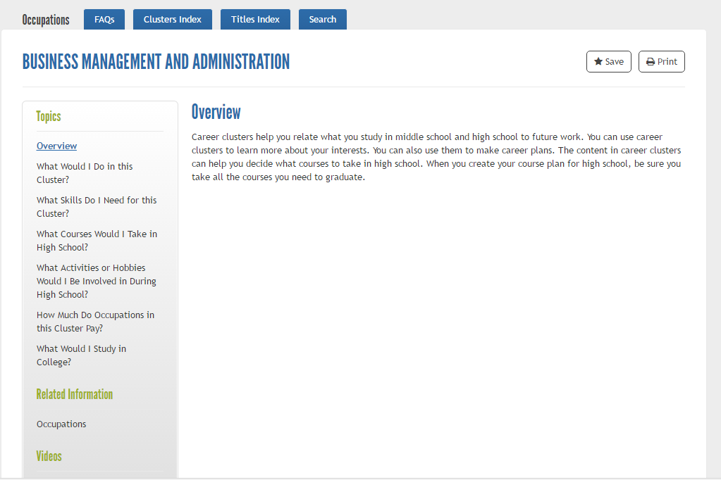

- Do “Occupations” research by clicking on the Occupations link associated with the cluster. A list of occupations will be displayed in alphabetical order.

- Ask students to pick an occupation that they are most interested in from this list and click on the link to find out more information about the selected occupation.

- Click on the links listed on the left side of the page under Topics to learn about the essential components of the selected occupation as well as how to prepare for this job.

    - What Will the Work Be Like?
    - Where Would I Work?
    - What Skills Do I Need?
    - How Much Would I Earn?
    - Will There Be Jobs in the Future?
    - How Do I Prepare?
    - What Should I Study?

- Students can also view the Occupation Videos to learn more about this occupation.

- Click the “SAVE” button to save this occupation in the student’s profile.

- If time allows, ask students to select another occupation and learn about this new occupation. Make sure to click “SAVE”.

